Combinational Circuits
A combinational circuit is a connected arrangement of logic gates with a set of inputs and outputs. At any given time, the binary values of the outputs are a function of the binary combination of the inputs.
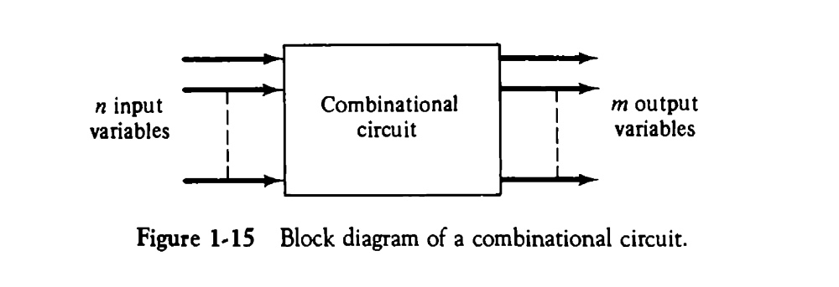
In the above diagram, the n binary input variables come from an external source, the m binary output variables go to an external destination, and in between there is an interconnection of logic gates.
Combinational circuits are employed in digital computers for generating binary control decisions and for providing digital components required for data processing.
A combinational circuit can be described by a truth table showing the binary relationship between the n input variables and m output variables. The truth table lists the corresponding output binary values for each of the 2^{n} input combinations
A combinational circuit can also be specified with m Boolean functions, one for each output variable. Each output function is expressed in terms of the n input variables.
The design of combinational circuits starts from the verbal outline of the problem and ends in a logic circuit diagram. The procedure involves the following steps:
1. The problem is stated.
2. The input and output variables are assigned letter symbols.
3. The truth table that defines the relationship between inputs and outputs is derived.
4. The simplified Boolean functions for each output are obtained.
5. The logic diagram is drawn.
To demonstrate the design of combinational circuits, we present examples of simple arithmetic circuits. They are

1. Half-Adder
The most basic digital arithmetic circuit is the addition of two binary digits. A combinational circuit that performs the arithmetic addition of two bits is called a half-adder.
The input variables of a half-adder are called the augend and addend bits. The output variables are the sum and carry. It is necessary to specify two output variables because the sum of 1 + 1 is binary 10, which has two digits.
We assign symbols x and y to the two input variables, and S (for sum) and C (for carry) to the two output variables.
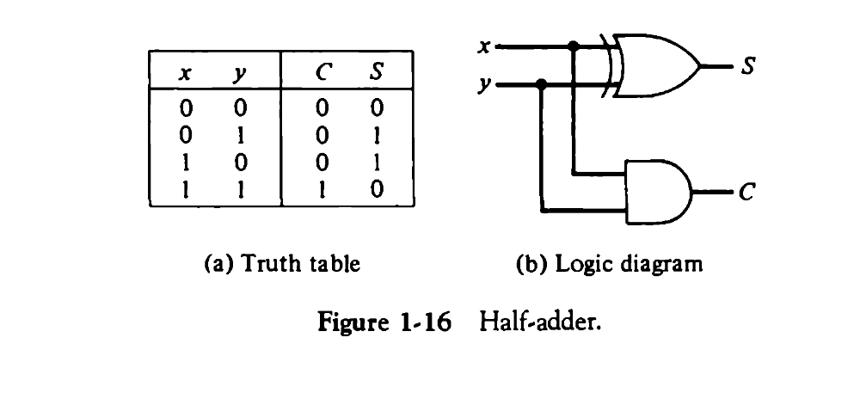
The truth table for the half-adder is shown in Fig. 1-16(a). The C output is 1 if both inputs are 1. The S output represents the least significant bit of the sum.
The Boolean functions for the two outputs can be obtained from the truth table are as follows:
S = x’y + xy’ = x y
C= xy
The logic diagram is shown in Fig. 1-16(b). It consists of an exclusive-OR gate and an AND gate.
Full –Adder
A full adder is a combinational circuit that forms the arithmetic sum of three input bits. It consists of three inputs and two outputs.
The truth table of the full adder is shown in Table 1-2. The eight rows under the input variables designate all possible combinations of three binary variables.
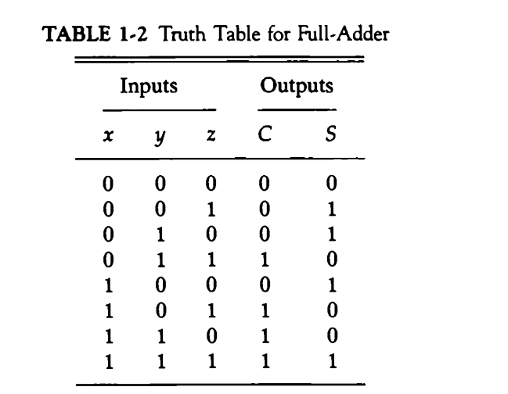
The values of the output variables are determined from the arithmetic sum of the input bits. The S output is equal to 1 when only one input is equal to 1 or when all three inputs are equal to 1. The C output has a carry of 1 if two or three inputs are equal to 1.
Algebraic expression for output variables are
S = x’y’z + x’yz’ + xy’z’ + xyz
S = xyz
(Since in a three input exclusive –OR function, the output is 1 if only one input is 1 or if all three inputs are 1.)
C = x’yz + xy’z + xyz’ + xyz
C= z(x’y + xy’) + xy(z’ + z)
C= z(xy) + xy

